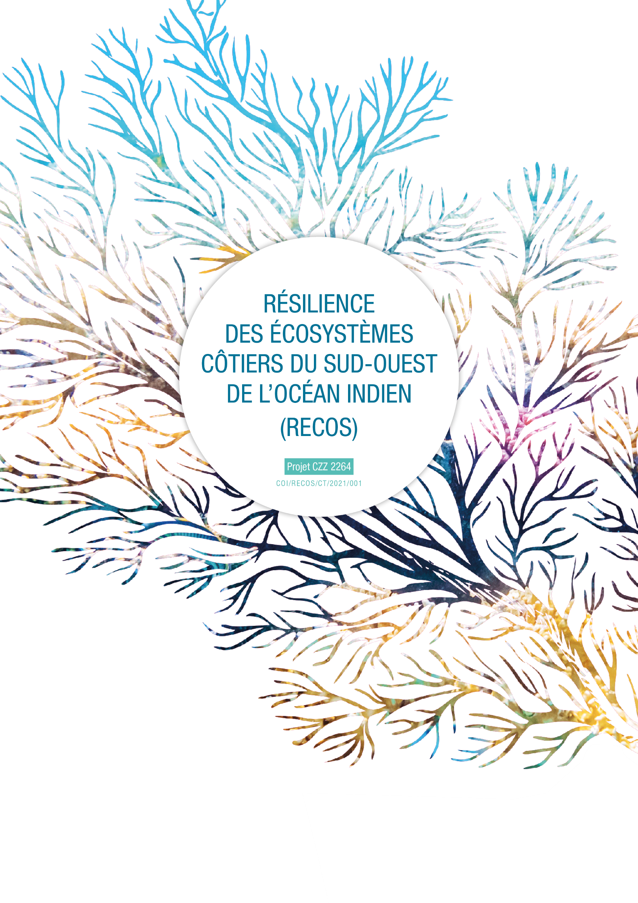

THE EXHANGE OF EXPERIENCES PROGRAMME ON COASTAL ECOSYSTEMS MANAGEMENT
APPLICATION FORM
APPLICANT IDENTITY :
Date of the day
Applicant / applicant organisation | Name of the applicant organisation or applicant for the exchange
Full contact details: | Postal address :  E-mail address :  Telephone number :  Website or social network :
Name of the exchange operation :
Themes concerned by the exchange :  (tick the theme(s) concerned) | - Strengthening the scientific component of the RECOS project:  MPA/LMMA management  Management and restoration of marine and coastal ecosystems (mangroves and seagrass )  Land-sea integration, ICZM approach  Coastal and marine environmental education  - Contribute to the implementation of pilot sites and projects identified in the framework of the RECOS call for projects:  Indicate here the title of the project you are contributing to :
Experience holder : | Name and contact details
Travel details : | Country/city of origin :  Country/city of destination :  Planned dates of travel :  Number of people participating in the trip :  Total estimated budget (€) :
First exchange operation funded by RECOS | Yes | Indicate the date and title of the previous exchange :  No
How you heard about RECOS and its exchange programme:

JUSTIFICATION OF THE APPLICATION :

Use as much space as necessary to argue your answers

- How are you involved in integrated coastal ecosystem management (IZCM) ?
- Specify the nature of your structure, your functions, your missions, your experience, and the link with the RECOS project themes.

2- What are the main aims of this exchange? What expertise do you like to develop?
- Specify why the expertise you are looking for is necessary for the implementation of your project
- Identify 3 clear aims for this exchange

3 main objectives for the exchange
Objective 1 :
Objective 2 :
Objective 3 :

3- How did you identify the experience holder? How does its experience/expertise correspond to your needs? Justify also that you cannot find this specific expertise closer to you (out of concern for your carbon footprint).

4- What will be the benefits and results of this exchange, and for whom? (at local, national and/or regional level).

5- How do you intend to implement the results of this operation in the months following the exchange? Outline at least 3 concrete actions achievable within a year. Note that RECOS will follow up on this action plan through 2 interviews scheduled at 6 months and 1 year after the exchange operation.
Post-exchange action plan
Action 1 :
Action 2 :
Action 3 :

6- Agenda of the operation:
- Detail the activities planned in consultation with the experience holder :

DATE | PLACE | PERSONS MET / VISITED SITES
Departure from the country :

Arrival in the host country :

Day 1 :

Day 2 :

Day 3 :

Day X : (add as many lines as days of travel)

1- Persons that benefit from the funding of the exchange:
Total number of people to travel: ............
SURNAME AND NAME  (as indicated on the identity document to be used for travel) | AGE | SEX | FONCTION | E-MAIL ADRESSE | JUSTIFICATION FOR PARTICIPATION IN THE TRIP | ID CARD OR PASSPORT (NUMBER) | EXPIRATION DATE OF ID CARD OR PASSPORT

- Estimated budget for the travel operation:

1. TRAVEL COSTS
Type of costs | Detail | Itinerary (place of departure, place of arrival, flight plan, etc.). | Unit cost | Number of travellers | Total cost
Plane | Departure flight
 | Return flight
Car/Boat | Departure journey
 | Return journey
SUBTOTAL

- ACCOMMODATION AND MEAL COSTS
Type of costs | Cost per night/day per person | Number of nights | Number of host people | Total cost
Accommodation
Meal
SUBTOTAL

- PURCHASE OF SMALL ITEMS AND LOGISTICS *
Type of costs | Number of units | Unit cost | Justification | Total cost
Equipement 1
Equipement 2
As many lines
as equipment
SUBTOTAL
*the need for this exchange operation must be justified
- ON SITE TRANSPORT
Type of costs | Unit cost per day | Number of units | Total cost
Car/motorcycle/boat rental
Fuel
Other additional costs
SUBTOTAL

- ADMINISTRATIVE COSTS*
Type of costs | Unit cost | Number of person concerned | Total cost
Visa
Insurance
Other
SUBTOTAL

*Please note that administrative costs will be refund once the exchange report has been received.
TOTAL COSTS (1+2+3+4+5)

+ 10% of the total for unexpected additional cost
TOTAL COSTS (1+2+3+4+5+unexpected additional costs)

